Military Funeral And Memorial:

Position Maps:
Funeral Positions for all Participants Pages 1 - 7

GLOSSARY:
Military Funeral And Memorial: Pages 8 - 12

# 1 Legend

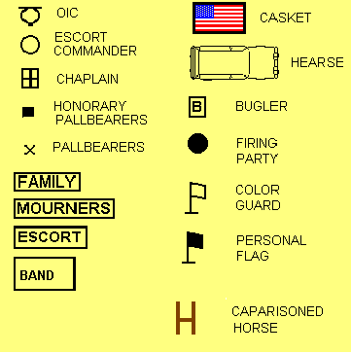

# 2 Arrival of The Casket

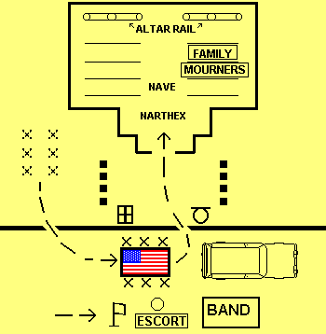

# 3 Chaplain Leads Processional

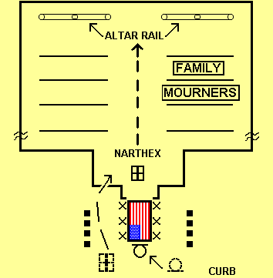

# 4 Escort of the Casket

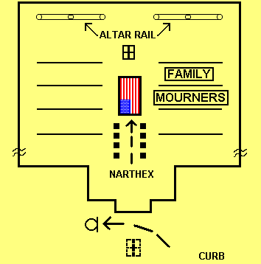

# 5 Interior Position of Elements

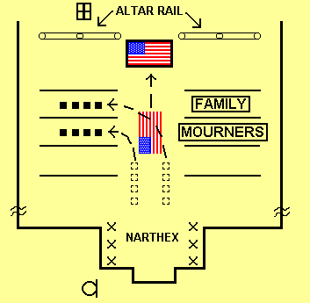

A. Honorary pallbearers occupy the front left pews upon placement of the casket.

B. If ushers take the deceased to and from the alter, pallbearers remain in the Narthex.

C. The OIC remains outside.

# 6 Elements Moving to The Hearse

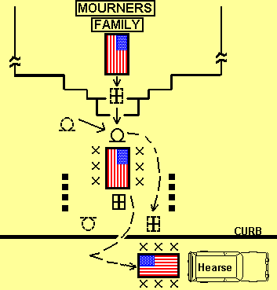

# 7.a. Processional to the Cemetery

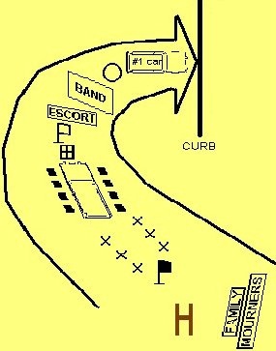

A. The cemetery representative’s vehicle leads the funeral procession.

B. The OIC should be waiting at the cemetery for the family.

# 7.b. At the Gravesite

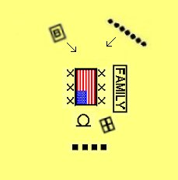

A. The Bugler plays Taps in the direction of the Family.

B. The Firing Party fires volleys over the Casket.

Military Funeral And Memorial: GLOSSARY

CAO/NCO: Casualty Assistance Officer/Noncommissioned Officer. The officer or NCO officially designated to assist the survivors of the deceased. Responsibilities of the CAO or NCO are detailed in AR 600-10 and the Army Casualty Systems, Chapter 7, Section II, paragraphs 7-8 through 7-15.

Caisson: A four wheeled horse-drawn wooden wagon utilized at Arlington National Cemetery for the purpose of transporting the remains of the deceased at military full honor funerals.

Caparisoned Horse: Utilized at Arlington National Cemetery at full military honor funerals, if the deceased was a member of a mounted unit or the rank of Colonel (0-6) and above.

Cinerarium: A place to receive the ashes of the cremated dead.

Columbarium: 1. A structure of vaults lined with recesses for cinerary urns. 2. A recess in a columbarium.

FUNERAL OIC/NCOIC: Officer or NCO In Charge - of the honor guard and burial detail assigned by the Casualty Assistance Office with responsibility for the proper conducting of military honors at the funeral.

Funeral Pall: Is a heavy liturgical cloth which is utilized as a draping over the casket during the religious portion of the funeral service inside the chapel and/or church.

Funeral Roster: At times, a chaplain will be assigned to funeral duty by the installation chaplain’s office or higher headquarters. In this case, the chaplain should perform his/her duties conscientiously, with care and pastoral compassion.

HOT WORDS: In this book you will find some words in the color BLUE. These words are active and linked with programming code to a Glossary Book. It is written in such a way as to display the definition page for the Hot Word term. The page will be suspended upon your Button Click and return you to the page of instruction.

A single Button Click with your mouse is all it takes.

Last Roll Call: A final tribute to a soldier, normally conducted at the closing of a Memorial Ceremony or Service, right before taps, whereby the unit First Sergeant ceremoniously conducts a roll call of two or three soldiers in the squad or platoon of the deceased. After each soldier replies, “Here First Sergeant,” the deceased’s name is called, representing that a soldier is missing from their ranks. It is an emotionally charged ceremony, each individual command must decide if this portion of the ceremony is included in the order of service, most SOP’s will indicate the preference.

Narthex: A vestibule/foyer entrance leading into the sanctuary of the church.

NOK: Next of Kin. The individual designated by the service member as next of kin.

Military Funeral: A religious ritual, proceeding burial, in accordance with the faith of the deceased and proper military protocol.

Military Memorial Ceremony: A patriotic and military ceremony to honor the deceased. Attendance may be mandatory.

Military Memorial Service: A religiously oriented service reflecting the preferences of the deceased. Attendance must be voluntary.

Notification Officer: The officer designated to inform the Next of Kin of a service member’s death. Note: This is not the chaplain.

RAET: Reconstitution Assessment and Evaluation Team (RAET). Is a team designed to assess the needs for reconstitution, which may include a Unit Ministry Team. The UMT’s role is to assess those subjective factors which affect unit cohesion and morale.

Reconstitution: Is a mission planned and implemented by the Commander to restore ineffective units to a desired level of combat effectiveness, commensurate with mission requirements and availability of resources and time.

Two basic types of reconstitution are reorganization and regeneration.

Regeneration: Is the infusion of either individual replacements and single items of equipment or an infusion of whole new units or subelements into a degraded organization, which is in a stand down posture.

Reorganization: Reorganization can be immediate or deliberate. Immediate reorganization quickly shifts assets and restores the unit to minimum levels of combat effectiveness. Deliberate reorganization occurs when greater resources are available and there is a need for a more intensive reorganization.

SOP: Standing Operating Procedure - Normally, unique and designed to fit the mission of the respective unit, division, and/or installation stipulating guidelines and procedures for formal ceremonies and events, i.e. memorial ceremonies and services.

UMT: Unit Ministry Team - A chaplain and chaplain assistant assigned to the same Army unit at any echelon.

YARMULKE: A skull cap worn especially by Orthodox and Conservative Jewish males in the synagogue, at home, or during a formal religious observance, i.e. a military funeral for a deceased Jewish soldier.

References:

AR 165-1, Chaplain Activities in the U.S. Army
AR 290-5, Army National Ceremonies
AR 600-8-1, Army Casualty and Memorial Affairs and Line of Duty Investigations
AR 600-10, The Army Casualty System
AR 600-25, Salutes, Honors, and Visits of Courtesy
AR 638-1, Disposition of Personal Effects of Deceased and Missing Persons
AR 638-30, Graves Registration Organization and Functions in Support of Major Military Operations
AR 638-40, Care and Disposition of Remains
AR 840-10, Flags, Guidons, Streamers, Tabards, Automobile and Aircraft Plates

FM 10-57F Soldier’s Manual, 57F Graves Registration Specialist
FM 10-63 Handling of Deceased Personnel in Theaters of Operation
FM 10-63-1 Graves Registration Handbook
FM 22-5, Drill and Ceremonies
FM 16-1, Religious Support Doctrine: The Chaplain and Chaplain Assistant

TC 16-2, Religious Support to Casualties, Memorial and Funeral Services
FC 16-51 BATTLE FATIGUE MINISTRY (FIELD CIRCULAR)

STP 16-71M1-SM, Soldier’s Manual, MOS 71M, Chaplain Assistant, Skill Level 1
STP 16-71M 2/5-SM-TG, Soldier’s Manual and Trainer’s Guide, MOS 71M, Chaplain Assistant, Skill Level 2/3/4/5

USACHCS RB 16-100, Unit Ministry Team (UMT) Handbook

DA Pam 1-1, State, Official, and Special Military Funerals

DOD Form 1380 U.S. Medical Card

Additional References:

Kubler-Ross, Elizabeth, On Death and Dying, MacMillan, N.Y. 1969.

Wolfelt, Alan D. Death and Grief: A Guide For Clergy, Accelerated
Development Inc., Publishers, Muncie, IN. 1988 (Note: This
book may be out of print, suggest that you check with the
publisher or at your local library.)

